May 16, 2024

Dear Community Leader,

Will You Stand with Us to Support the Kids of Fontana?

In times of tragedy and crisis, Boys & Girls Clubs have stepped up to provide safe places for kids and teens. Today, the Boys & Girls Club of Fontana is committed more than ever to ensure Club staff, members, families, and communities have the resources and support they need to navigate these uncertain times.

On a typical day, Boys & Girls Clubs of Fontana serves youth ages 5 to 18 at 1 Clubhouse, 3 school-based sites and 1 housing site. The Club provides programs and services to over 400 youth daily and share resources with parents and families.

We invite you to join us as a sponsor for this year’s events…

Our sponsorship package includes Driving for Great Futures TOPGolf fundraiser on Thursday, June 27, 2024, and Boys & Girls Club Golf Classic to be held at Sierra Lakes Golf Club Monday, August 26, 2024, and The Mayor’s Great Futures Gala benefiting the Boys & Girls Club Winter 2024 at Spaggi’s Event Center in Fontana.

All donations are tax deductible, and we welcome donations in any amount. The recommended sponsorship levels can be found on the following page.

I look forward to hearing from you soon.
Best Wishes,
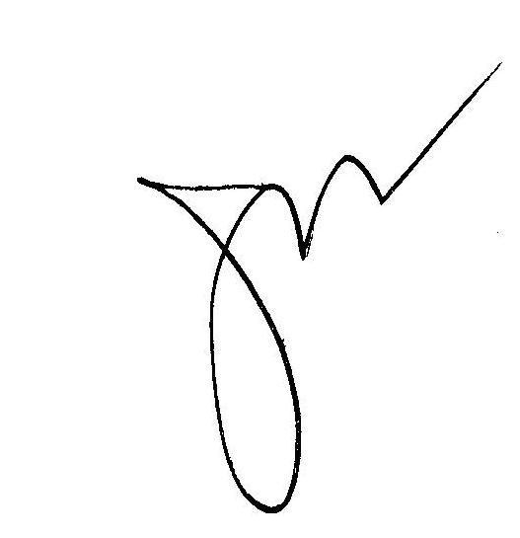
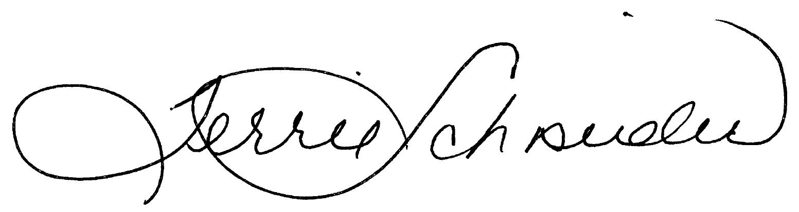

Josh LaBarge Terrie Schneider
President, Boys & Girls Club of Fontana CEO, Boys & Girls Club of Fontana

Platinum Sponsorship: $30,000

Hole-N-One Sponsorship at the Driving for Great Futures TOPGolf Tournament on June 27, 2024, which includes four (4) bays; Title Sponsorship at the 2024 BGCF Golf Classic on August 26, 2024, which includes four (4) foursomes; Diamond Sponsorship which includes Ten (10) Gala tickets. Name and Logo recognition on all promotional materials for all events prior to and throughout the events.

Gold Sponsor: $20,000

Eagle Sponsorship at the Driving for Great Futures TOPGolf Tournament on June 27, 2024, which includes three (3) bays; Corporate Sponsorship at the 2024 BGCF Golf Classic on August 26, 2024, which includes three (3) foursomes; Emerald Sponsorship which includes Eight (8) Gala tickets. Name and Logo recognition on all promotional materials for all events prior to and throughout the events.

Silver Sponsor: $10,000

Bridie Sponsorship at the Driving for Great Futures TOPGolf Tournament on June 27, 2024, which includes two (2) bays; Executive Sponsorship at the 2024 BGCF Golf Classic on August 26, 2024, which includes two (2) foursomes; Ruby Sponsorship which includes Six (6) Gala tickets. Name and Logo recognition on all promotional materials for all events prior to and throughout the events.

Bronze Sponsor: $5,000

Par Sponsorship at the Driving for Great Futures TOPGolf Tournament on June 27, 2024, which includes one (1) bay; Major Sponsorship at the 2024 BGCF Golf Classic on August 26, 2024, which includes one (1) foursomes; Opal Sponsorship which includes four (4) Gala tickets. Name and Logo recognition on all promotional materials for all events prior to and throughout the events.

President’s Club: $3,000

Team Sponsorship at the Driving for Great Futures TOPGolf Tournament on June 27, 2024, which includes one (1) bay; Team Sponsorship at the 2024 BGCF Golf Classic on August 26, 2024, which includes one (1) foursome; Sapphire Sponsorship which includes Two (2) Gala tickets. Name and Logo recognition on all promotional materials for all events prior to and throughout the events.

Maximize your promotional benefits by signing up early!
All sponsorships must be received no later than June 24, 2024 to receive promotional opportunities for TopGolf.

Sponsorship Level Desired: Platinum Gold Silver Bronze President’s Club

BUSINESS NAME

ADDRESS CITY/ZIP

CONTACT NAME PHONE

EMAIL WEBSITE

NAME ON CREDIT

MC VISA AMEX CARD # Exp. Date CVV code

